**AMPLITUDE MODULATION AND DEMODULATION**

**Experiment No. :** **6 Date : 19-02-2019**

**Aim :** To perform amplitude modulation and demodulation for modulation index m > 1 , m = 1 and m < 1.

**Program :**

t = 0:0.01:10*%pi;

Ac = 10;

Am = 5;

mi = Am/Ac;

Fm = 0.1;

Fc = 2;

Wc = 2*%pi*Fc*t;

Wm = 2*%pi*Fm*t;

function **l**=a(**t**), **l** = Am*cos(Wm) ,endfunction;

subplot(6,1,1);

plot(a(t));

title('Messgae');

function **m**=b(**t**), **m** = Ac*cos(Wc) ,endfunction;

subplot(6,1,2);

plot(b(t));

title('Carrier');

function **n**=c(**t**), **n** = Ac*(1 + mi*cos(Wm)).*cos(Wc) ,endfunction;

subplot(6,1,3);

plot(c(t));

title('Modulated for MI < 1');

function **o**=d(**t**), **o** = b(**t**).*c(**t**) ,endfunction;

filt = ffilt('lp',50,0.01);

message = filter(filt,1,d(t));

title('Demodulated');

subplot(6,1,4);

plot(message);

Ac = 10;

Am = 10;

mi = Am/Ac;

function **n**=c(**t**), **n** = Ac*(1 + mi*cos(Wm)).*cos(Wc) ,endfunction;

subplot(6,1,5);

plot(c(t));

title('Modulated for MI = 1');

Ac = 10;

Am = 20;

mi = Am/Ac;

function **n**=c(**t**), **n** = Ac*(1 + mi*cos(Wm)).*cos(Wc) ,endfunction;

subplot(6,1,6);

plot(c(t));

title('Modulated for MI > 1');

**Output of Code :**

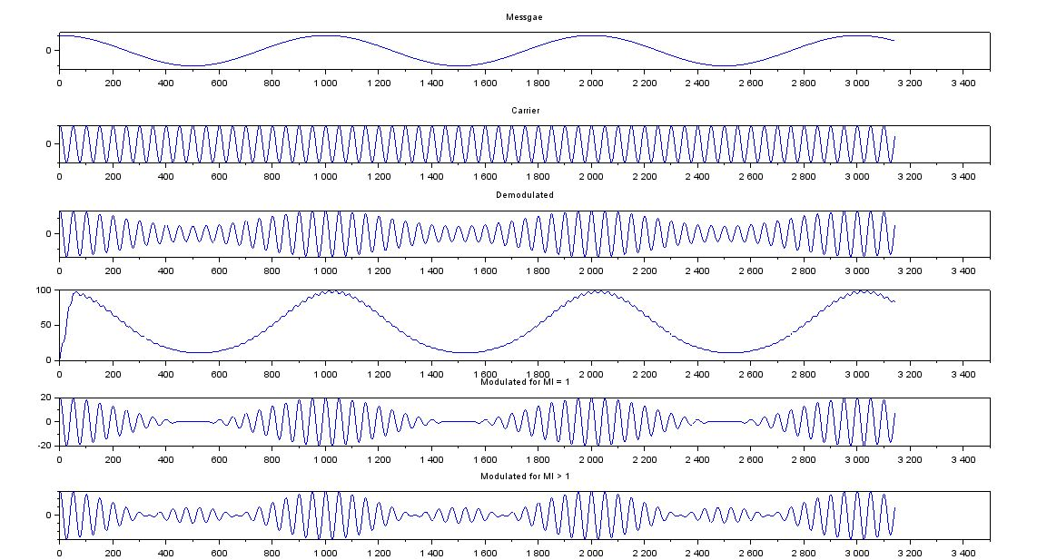

**Conclusion :** We have taken message signal and carrier wave of low and high frequency respectively. We performed amplitude modulation for the message and carrier signal and obtained and modulated signal and then by multiplying the modulated signal with carrier signal and passing it through low pass filter we obtained the message signal in the form of demodulated signal.